Create New Mobile Service

Download offline file using se38 program

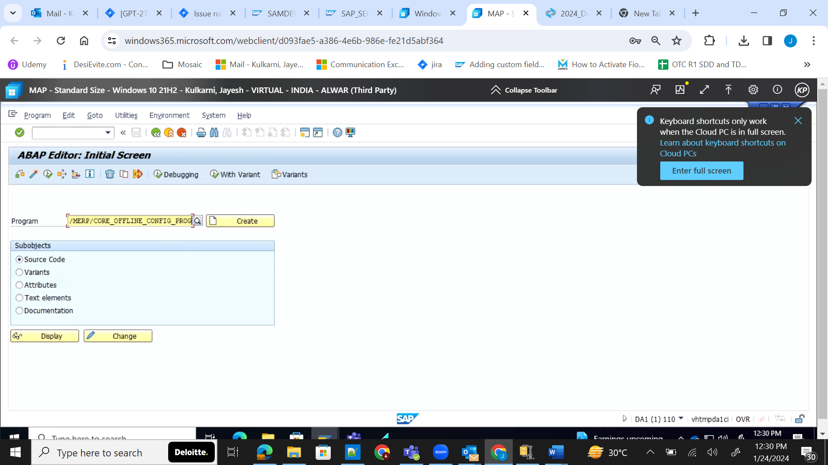

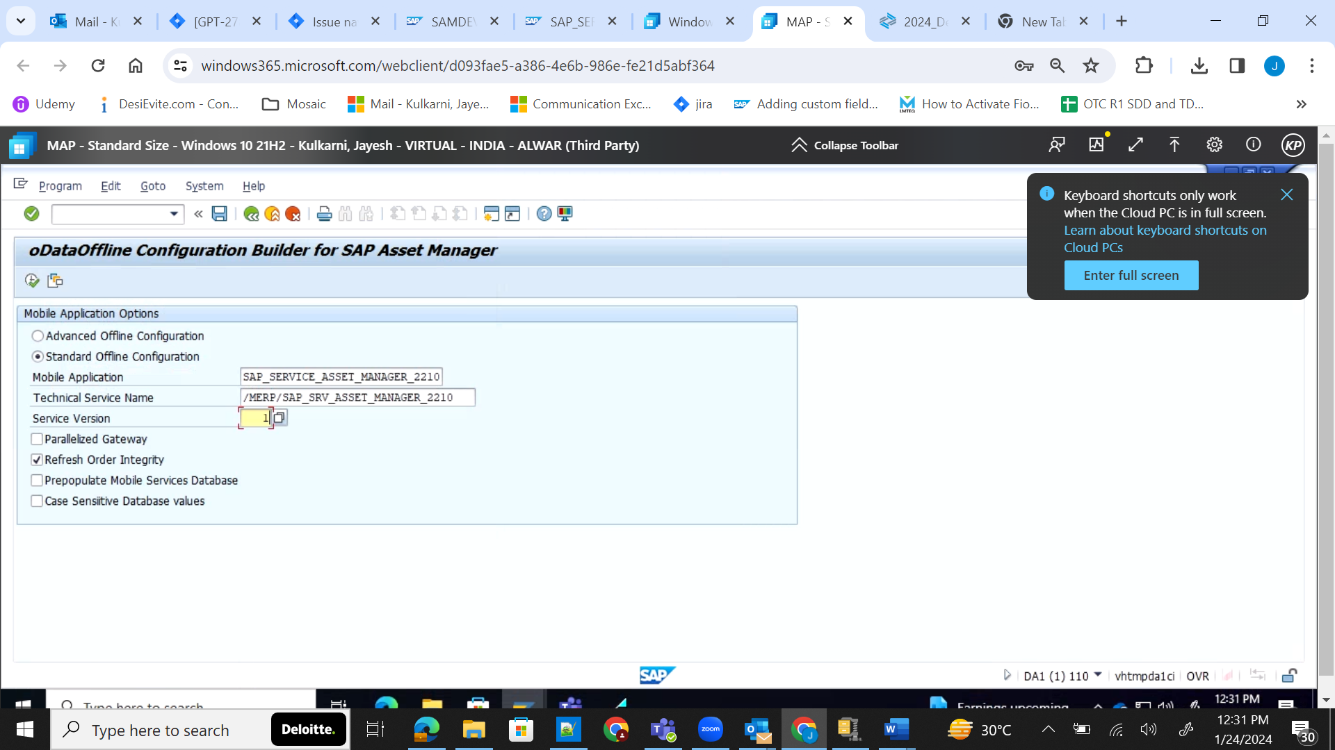

Create new mobile service using reference from other mobile service.
Create same destinations using mobile connectivity.
In offline access upload the downloaded file
API QR code shows wrong url, maintain samclient from application links
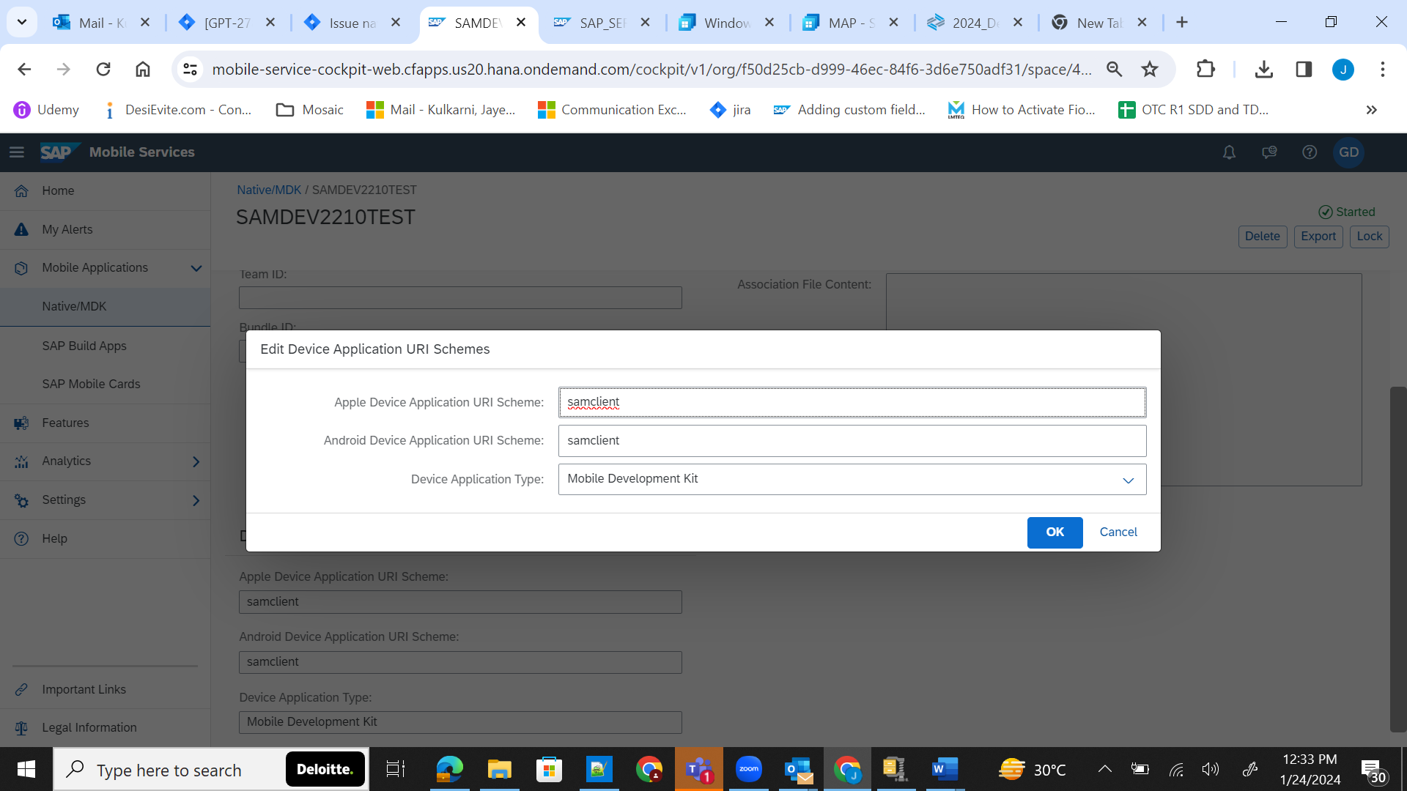

Sylo Configs for operation status
Visit Mobile application configuration then Mobile Status Settings and Parameters tab
In OMDO visit sam2210 then sam_overall_status service and data filter tab then status_state_machine

